Department of Computer Science and Engineering
The University of Texas at Arlington
Sliding Profiler
Architecture Design Specification

The Builders Group Ltd.

Team Members:
Chudamani Aryal
Lloyd Bond
Tyler Buchanan
Jefferson White
Late Updated: d MMMM yyyy 41164.6423611111 h:mm:ss am/pm
Copy Printed: d MMMM yyyy 41152.9861111111 h:mm:ss am/pm

Table of Contents
1 Sliding Profiler 7
1.1 Document Overview 7
1.2 Product Scope and Overview 7
1.3 Project Architecture Concepts 9
1.4 Project Architecture Scope 9
2 Meta Architecture Overview 10
2.1 Overview 10
2.2 Vision 11
2.3 Guiding Principles 11
2.4 Assumptions and Tradeoffs 11
3 Input Layer 13
3.1 Overview 13
3.2 Purpose 13
3.3 Function 13
3.4 Dependencies 14
3.5 Interfaces 14
3.6 Processing 14
3.7 Data 14
4 Processing Layer 15
4.1 Overview 15
4.2 Purpose 15
4.3 Function 16
4.4 Dependencies 16
4.5 Interfaces 16
4.6 Processing 16
4.7 Data 16
5 Storage Layer 17
5.1 Overview 17
5.2 Purpose 18
5.3 Function 18
5.4 Dependencies 18
5.5 Interfaces 18
5.6 Processing 18
5.7 Data 18
6 Output Layer 19
6.1 Overview 19
6.2 Purpose 19
6.3 Function 20
6.4 Dependencies 20
6.5 Interfaces 20
6.6 Processing 20
6.7 Data 20
7 GUI Layer 21
7.1 Overview 21
7.2 Purpose 21
7.3 Function 21
7.4 Dependencies 22
7.5 Interfaces 22
7.6 Processing 22
7.7 Data 22
8 Inter-Subsystem Data Flow 23
8.1 Overview 23
8.2 Data Flow 23
8.3 Producer/Consumer Relationships 24
9 Requirement Mapping 26
10 Input Layer Subsystems 28
10.1 Sensors 28
10.2 Power Input 28
10.3 A/D layer 29
10.4 UIC 29
10.5 Data Handler 30
10.6 Net Comm. 31
11 Processing Layer Subsystems 32
11.1 ALGO 32
11.2 Raw to Operation Data 33
11.3 Data Handler 33
12 Storage Layer Subsystems 35
12.1 Data Manager 35
12.2 Data Handler 35
12.3 Physical Storage 36
13 Output Layer Subsystems 38
13.1 Data Handler 38
13.2 Hardware Out 39
13.3 Net Comm. 39
14 GUI Layer Subsystems 41
14.1 Display 41
14.2 Librarian 41
14.3 File Storage 42
14.4 Net Comm. 43
14.5 Local Storage 43
15 Operating System Dependencies 45
15.1 GUI Layer 45
15.2 Input Layer 45
15.3 Output Layer 45
15.4 Storage Layer 45
15.5 Processing Layer 45
16 Testing Considerations 46
16.1 General 46
16.2 Testing Approach 46

List Of Figures
Figure 1 - Product Concept 7
Figure 2 - Meta Architecture Overview 10
Figure 3 - Input Layer 13
Figure 4 - Processing Layer 15
Figure 5 - Storage Layer 17
Figure 6 - Output Layer 19
Figure 7 - GUI Layer 21
Figure 8 - Inter Subsystem Data Flow Diagram 24

List Of Tables
Table 1 - Processing Layer Interfaces 16
Table 2 - Storage Layer Interfaces 18
Table 3 - Output Layer Interfaces 20
Table 4 - Data Flow Descriptions 23
Table 5 - P/C Relationship 25
Table 6 - Requirement Mapping 27
Table 7 - Input Layer - Power Input Public Interfaces 29
Table 8 - Input Layer - Data Handler Inter-Layer Interfaces 30
Table 9 - Input Layer - Net Comm. Inter-Layer Interfaces 31
Table 10 - Processing Layer - Data Handler Inter-Layer Interfaces 34
Table 11 - Storage Layer - Data Handler Inter-Layer Interfaces 36
Table 12 - Output Layer - Data Handler Inter-Layer Interfaces 38
Table 13 - Output Layer - Hardware Out Public Interfaces 39
Table 14 - Output Layer - Net Comm. Inter-Layer Interfaces 40
Table 15 - GUI Layer - Display Public Interfaces 41
Table 16 - GUI Layer - Net Comm. Inter-Layer Interfaces 43

Document Revision History
Revision Number | Revision Date | Description | Rationale
0.1 | 9/11/2012 | First Draft | Submitted for Peer Review
1.0 | 9/12/2012 | Second Draft | Submitted for Gate Review

Sliding Profiler

Document Overview
The Architectural Design Document will provide a high level description of the Sliding Profiler based on the system requirements. This document will provide the base for developers to delve into the detailed requirements and design of the product. It will further discuss the scope and concept of the product and provide an insight on the various layers and components of the system. It will also provide detailed description of the inter-subsystem data flows and relationships. Finally, testing considerations shall be discussed in the later sections of the document. The aim here is to enable an abstraction in the detailed design process between the systems so that changes in one system require little to no change in other systems.

Product Scope and Overview
This section provides the reader with an overview of the Sliding Profiler. The Sliding Profiler is a wet concrete bump detection product that aggregates data from many sensors to determine the probable smoothness of the freshly laid road. Before the concrete has dried, the operators will know if the concrete has met the state requirement for smoothness of concrete roads. The Sliding Profiler will use various sensors to determine if the freshly poured concrete has any bumps unfit for vehicular travel. Our expectations are the Sliding Profiler will follow a cement spreader detecting inclination and distance, and then notify concrete smoothers of detected bumps to be smoothed. The Sliding Profiler will benefit construction contractors who specifically specialize or intend to build concrete highway or road. The Sliding Profiler will need to be made available commercially.

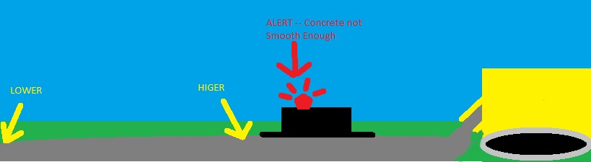
Figure 1 - Product Concept

The Sliding Profiler system will feature/use the following components:
- Sled: - The sled portion of the profiler is the part of the product that glides across wet road surface. It provides a platform for which the profiler electronics and sensors can function and collect data.
- Electronics Housing:- The electronic housing is responsible for providing a secure mounting platform for all the sensors and circuitry. It is also responsible for protecting the electronics from the elements.

- Sensors:-
  - Inclinometer - The inclinometer is responsible for reacting to the angle of the platform and providing a voltage signal that the software system will use for operational data.
  - Distance Sensor - The distance sensor is responsible for translating the distance traveled into a voltage signal that the software system will use for operational data.
  - Temperature Sensor - The temperature sensor is responsible for reading the temperature inside of the electronics housing and providing a voltage signal that the software system will use for error checking.

- Display:- The display subsystem is responsible for providing the user with a visual indicator about the current state of the Sliding Profiler as well as alerts to detected bumps.

- Communications:- The communications subsystem is responsible for transmitting/receiving data to/from the client software. It is also responsible for communicating with the various hardware peripherals.

- Processor:- The processor subsystem is responsible for executing instructions from the Software system.

- Storage:- The storage subsystem is responsible for storing operational data on a non-volatile medium that will be read by the client software. It is also responsible for storing all calibration and configuration information for future use.

- Cooling:- The cooling subsystem is responsible for ventilating the electronics housing.

- Power Distribution:- The power distribution subsystem is responsible for providing the necessary and proper power to all subsystems requiring a separate power source. The power source is provided externally from road paver.

- Client PC:- The client PC provides the operating system for the software subsystems intended for use by a technician. See the Software system for detailed information.

Project Architecture Concepts
The Sliding Profiler will be built on a flat smooth base, possibly something like a snowboard or wake board. The entire product will be light enough to float on wet concrete with minimal disruption. There will be an attached distance wheel for tracking distance traveled, coupled with an inclinometer to sense changes in concrete height. Gathered data will be processed and transmitted to a client machine for reviewing the processed data (e.g. the location of the bumps) and pure raw data analysis.

Project Architecture Scope
The Sliding Profiler is currently realized as a prototype used by TxDOT contractors. It is designed to slide behind a road paving machine to measure and indicate sharp bumps in the pavement that would cause poor ride quality. The scope of this effort is to replace and redesign the key components of this product.

Meta Architecture Overview

Overview
The system consists of five layers: Input Layer, Process Layer, Storage Layer, Output Layer and GUI Layer. The Input Layer gets all the inputs from the sensors as well as the end users. The Process Layer is responsible for processing all the input/raw data. Once the data has been processed, the data is sent to the Storage Layer and Output Layer. The Storage Layer is responsible for managing and storing raw/processed data. It is also responsible for making stored data readily accessible, if needed by the end users. The Output Layer is responsible for displaying the result through hardware lights and sending the results to network communications. The GUI Layer is responsible for displaying the results/data on PC. It is also responsible for getting inputs from the user, which are transferred back to Input Layer via network communications.
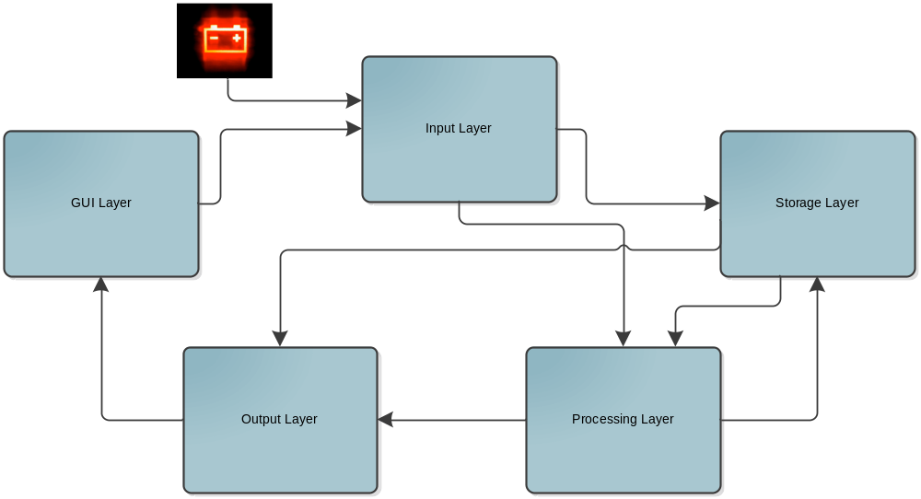
Figure 2 - Meta Architecture Overview

Vision
The main goal of this design is to make sure that each layer has one logical function. For example, the Input Layer gets all the inputs from the sensors as well as the end users. Also another vision of the design was to make sure that the design was easy to implement. We made sure that each layer and subsystem was clear and well defined with logical functions and roles.

Guiding Principles

- Modularity
- Staged delivery
- Layers and subsystems with clear, well-defined logical roles
- Extensibility:- Easy to add future items/requirements
- Compatible with System Requirement Specification
- Interface with PC only
- Easy integration
- Have stand-alone mode as well
- Safe for end users

Assumptions and Tradeoffs

Assumptions
- Product will operate in all weather related conditions applicable for laying concrete.
- Product will be stored in varied temperature range.
- Product may be exposed to temperature extremes other than the above cases. E.g. Alaska(cold),Texas(hot).
- Product will be returned to an authorized maintenance authority for servicing (technician) and calibration (support-user).
- Product will not be serviced on location.
- Maintenance authorities (technicians) will have the means to properly test recalibrated Products before returning them to service.
- Power will be made available for the Product from the road paver.
- Product need only maintain a window of sensor history in memory to detect bumps.
- Product need not contain an audible bump indicator.
- Product will not have any sort of display other than indicator lights on the actual platform; all display will occur on a remote system.

Tradeoffs
- Initially, we had a single Output Layer for both display as well as GUI. Later we changed to two different layers because GUI had a different logical role than Output Layer.
- There are different platforms that we could have chosen to design the GUI for, but we decided to limit ourselves to a PC due to time constraints in Senior Design. We also chose this since we are only trying to finish a working concept, and felt that designing for a more complex platform (eg. Tablets or mobile devices) would be gold plating.
- We decided to include a file system in our storage layer, which will allow us to remove the storage and read it from the GUI layer. The other option would be creating our own easy to use format in the storage layer, but we want to ensure the storage can be removable and read in the GUI.

Input Layer

Overview
This layer contains inputs from such areas as sensors, power, and UIC. The sensors will be the main source of input as it contains information such as GPS, temperature, distance, and angle. All these inputs will then be packaged and sent to the Process layer.

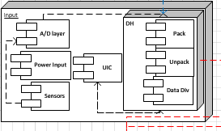
Figure 3 - Input Layer

Purpose
The input layer shall handle all input devices from all sources. The data collected will be stored, processed, or displayed from this layer to the next. The main goal is to maintain operations through collecting data and transmit data effectively.

Function
The layer is responsible for collection, packaging, and sending data to its destination.

Dependencies
The input layer will depend upon all sensors, power input, and communication with other layers to perform correctly. If any part should fail then an error should occur and trigger an error code and then stop processing data under certain conditions.

Interfaces
Only the network interface and sensor interface will be available at this layer.

Processing
The input layer will process data into data packages which will be sent to the processing layer and storage layer. It will also process analog sensors to digital signals and then packaged for internal or GUI use.

Data
- Distance wheel
- Temperature
- Angle
- GPS
- GUI input

Processing Layer

Overview
The processing layer provides the function of processing raw data to produce meaningful results. The layer primarily runs the bump detection algorithm.

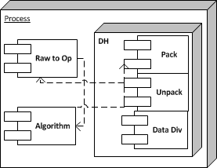
Figure 4 - Processing Layer

Purpose
The purpose of the processing layer is to process the incoming stream of sensor data in real time to detect when it indicates a bump based on the user input configuration that defines a bump. The processing layer shall be the sole component that analyzes the sensor data, and the only place that provides bump detection for the system.

Function
The processing layer receives raw sensor data from the input layer, processes it, and sends the processed data (including bump detection information) to both the storage layer and the output layer.

Dependencies
The processing layer depends on the microcontroller to provide processing power. The function of the data processing will be determined by the bump detection algorithm provided by Dr. Walker.

Interfaces
Interlayer interfaces will be handled with the Data Handler subsystem in the processing layer. The processing layer will interface with the other layers as follows:

Table 1 - Processing Layer Interfaces
Source | Destination | Data
Input Layer | Processing Layer | Packaged Raw Sensor Data (Inclinometer, Distance Encoder, Temperature etc.)
Processing Layer | Output Layer | Packaged Processed Data, including bump detection flags
Processing Layer | Storage Layer | Packaged Processed Data, including bump detection flags

Processing
The layer handles processing of raw data, to operational data, and to processed data.

Data
The layer takes raw sensor data as input, converts it into operational data, and then using the bump detection algorithm to generate processed data. This processed data is then sent to the output layer and the storage layer.

Storage Layer

Overview
The storage layer is in charge of keeping and managing both the raw and processed data that the system acquires. It will maintain the physical storage of the data in an orderly manner, and provide this data on request.

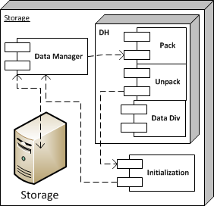
Figure 5 - Storage Layer

Purpose
The purpose of the storage layer is to provide a means to keep a history of raw and processed data that has been collected by the system so that it can be retrieved later.

Function
The storage layer maintains the physical storage, include initializing the file system. The layer receives live packets of the raw data and processed data, and keeps them on the physical storage. When requested, the storage layer will provide the stored data to the output layer.

Dependencies
The storage layer will depend on some TBD file format to manage the physical storage.

Interfaces
Interlayer interfaces will be handled with the Data Handler subsystem in the storage layer. The storage layer will interface with the other layers as follows:

Table 2 - Storage Layer Interfaces
Source | Destination | Data
Storage Layer | Output Layer | Requested stored data, raw and processed
Processing Layer | Storage Layer | Data processed by bump detection algorithm
Input Layer | Storage Layer | Requests for stored data, also raw sensor data

Processing
The storage layer will process requests for stored data.

Data
The storage layer will keep track of raw sensor data from the input layer and processed data from the processing layer.

Output Layer

Overview
The output layer provides output regarding bump detection, error conditions, and normal operation to the user. It also controls networking with the GUI layer to provide information such as raw and processed data as output to the GUI.

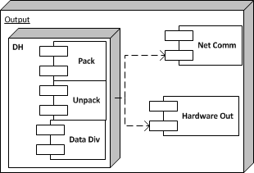
Figure 6 - Output Layer

Purpose
The purpose of the output layer is to convey the output of the system to the user. It does this with the lights on the platform (bump detection light and heartbeat in Hardware Out subsystem) and also provides output to the GUI layer so it can be viewed.

Function
The output layer receives packaged raw and processed data from the input layer and processing layer. It uses the processed data to run the lights on the platform appropriately. It also relays this data to the GUI layer over the network when connected. This data can be both live data and stored data.

Dependencies
The output layer depends on the implementation of the GUI/Platform network to provide a connection to the GUI for output.

Interfaces
Interlayer interfaces will be handled with the Data Handler subsystem in the output layer. The output layer will interface with the other layers as follows:

Table 3 - Output Layer Interfaces
Source | Destination | Data
Storage Layer | Output Layer | Stored system data (raw and processed) to be sent to GUI
Input Layer | Output Layer | Live raw sensor data
Processing Layer | Output Layer | Live data processed by bump detection algorithm
Output Layer | GUI Layer | System data, raw and processed, live and stored

Processing
The only processing taking place in the output layer is data flow management. The data received in this layer must be passed to either the hardware out or GUI.

Data
The Output Layer receives stored and live system data, including raw sensor data and data processed by the bump detection algorithm. The Output layer sends this data to the GUI layer.

GUI Layer

Overview
The GUI layer is the only layer of the system that runs independently of the physical platform. The GUI layer operates on a PC connected to the system over a network. Both raw and processed data can be displayed and analyzed through the GUI, providing an easy way for the user to check the results. It also allows the user to provide input to configure the device.

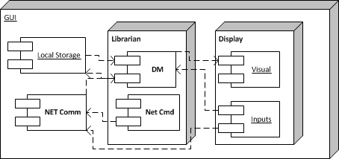
Figure 7 - GUI Layer

Purpose
The purpose of the GUI layer is to provide an easy to use interface with the user, and display all relevant data from the system in an easy to follow manner. The GUI layer can view live data as it is streamed from the running system, or saved data from the system through either the network or removable storage. The GUI layer also allows the user to configure the device.

Function
The GUI layer is given the data of the system from the Output layer, and stores the data using the PC file system. This data is analyzed and displayed in the GUI to the user. The GUI also has the ability to read data from the Local Storage subsystem which allows the systems removable storage to be connected. Finally, the GUI also provides the function for the user to configure the system (User Input Configuration) via easy to use GUI inputs.

Dependencies
The GUI layer is dependent on the Windows operating system to provide a storage system to hold data, a run time GUI application and the underlying network capabilities to allow a connection with the system.

Interfaces
Interlayer interfaces will be handled with the Data Handler subsystem in the GUI layer. The GUI layer will interface with the other layers as follows:

Source | Destination | Data
GUI Layer | Input Layer | Requests for stored system data, and User Input Configuration data
Output Layer | GUI Layer | System data, raw and processed, live and stored

Processing
This layer will have no processing capabilities.

Data
The GUI layer receives system data (raw and processed, live and stored) to be viewed. Sends stored data requests and User Input Configuration Data.

Inter-Subsystem Data Flow

Overview
The inter-subsystem data flow shows how data elements are related with the sub-systems in each layer. This is the means of showing how each subsystem is inter-connected and inter-related with each other. It also signifies the nature and direction of the data that flows within the subsystem. Here, a special two character designator followed by an integer represents the internal and outgoing data elements for a specific subsystem of the layers. All data elements beginning with “ST” refer to the Storage Layer, data elements beginning with “PR” refer to the Processing Layer, data elements beginning with “OU” refer to the Output Layer, data elements beginning with “IN” refer to the Input Layer, and data elements beginning with “GU” refer to the GUI Layer.

Data Flow
Table 4 - Data Flow Descriptions
Data Element | Data Description
GU 1 | Formatted data (raw, processed) sent to GUI display
GU 2 | Formatted data (algorithm variables) sent to input layer
GU 3 | Communication between DM and Input component
GU 4 | Data being sent to be displayed
GU 5 | Transaction of data to be sent to the data manager
GU 6 | Formatted data being sent to the DM to be stored on local storage
GU 7 | Packaged data to be sent out to different layers
IN 1 | Network communication between GUI and Input Layer
IN 2 | Formatted data being sent to the DM for transmission to the Process layer
IN 3 | Raw data sent to be transform data from analog to digital
IN 4 | Input configuration file communication line to be used in the process layer
OU 1 | Formatted processed data to be sent packaged for network communication
OU 2 | Packaged data to be sent out to the GUI layer
OU 3 | Commands to be sent to the hardware
PR 1 | Communication between Input and process layer
PR 2 | Communication between process and storage layer
PR 3 | Processed data to be sent for packaging
PR 4 | Format raw data to operational data
PR 5 | Operational data to be sent for processing
ST 1 | Processed operational data to be stored
ST 2 | Command to initialize storage
ST 3 | Unpacked command to initialize
ST 4 | Stored data to be packaged
ST 5 | Communication line between Data manager and physical storage

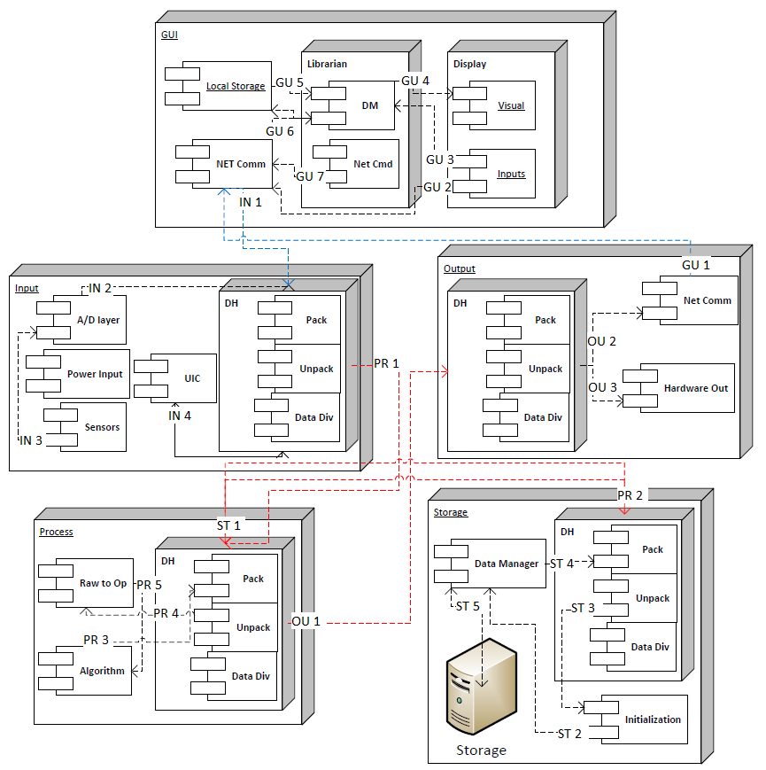
Figure 8 - Inter Subsystem Data Flow Diagram

Producer/Consumer Relationships
The producer-consumer relationships define the communication paths between sub-components within the system. The following table identifies the relationships which are detailed further by referring to section 8.2.

Table 5 - P/C Relationship
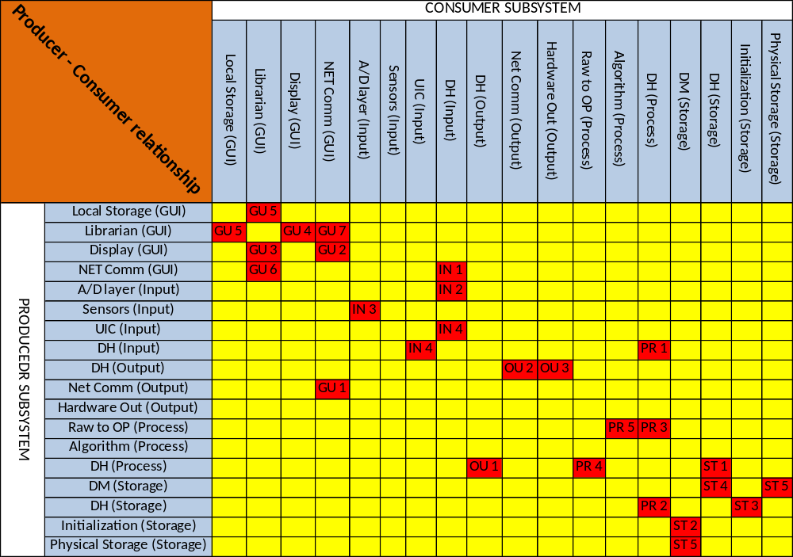

We can see that the above Producer Consumer Relationship figure depicts the data elements’ flow within subsystems. Here, rows denote the producer subsystem from where data generates, and columns denote the consumer subsystem which receives the data. For instance GU 1 is the formatted data (raw, processed) sent to GUI display for viewing.

Requirement Mapping
The purpose of the requirement mapping is to give an overview of the requirements specified in System Requirement Specification that are intended to be satisfied based on the Architecture Design Specification’s subsystems.

Table 6 - Requirement Mapping
Number | Requirement | Storage Layer | Process Layer | Input Layer | Output Layer | GUI Layer
3.1 | Power on/off easily |  |  | X
3.2 | Not operate after a critical error | X | X | X | X | X
3.3 | Visually indicate error conditions |  |  |  | X
3.4 | Indicate when it is operating normally |  |  |  | X
3.5 | Measure the travel distance of the platform |  |  | X
3.6 | Measure the inclination of the platform from a calibration point |  |  | X
3.7 | Generate operational data from the raw data of the sensors |  | X
3.8 | Transfer operational data to the client application in real-time |  |  |  | X
3.9 | Detect bumps in concrete pavement |  | X
3.1 | Operate in extreme temperatures | X | X | X | X | X
3.11 | Measure the internal temperature of the electronics housing |  |  | X
3.12 | Use an embedded PIC microcontroller w/ networking | X | X | X | X
3.13 | Store operational data | X
3.18 | Must run on a PC |  |  |  |  | X
3.19 | Display operational data |  |  |  |  | X
3.2 | Read stored data | X |  |  |  | X
3.21 | Calibrate sensors |  |  |  |  | X
3.22 | The client application can configure the PIC microcontroller |  |  |  |  | X
3.23 | The configuration process is abstracted from the end-user |  | X
3.24 | User-friendly client application |  |  |  |  | X
3.26 | Able to operate in a stand-alone mode | X | X | X | X
3.27 | Visually indicate a bump using a beacon light |  |  |  | X
3.29 | Use GPS to track the bump location |  |  | X

Input Layer Subsystems

Sensors

General
The sensors of his system include Temperature Sensor, Distance Encoder, Inclinometer, and GPS. These sensors measure the external world, and provide electrical input to the system.

Assumptions
We assume the sensors measure accurately, and that the temperature and distance inputs are digital and the inclinometer is analog.

Responsibilities
The sensor subsystem is responsible for providing accurate measurements of the environment to the system.

Subsystem Inter-Layer Interfaces
None.

Subsystem Public Interfaces
The sensors subsystem is 100% internal. There will be no public access to this interface.

Power Input

General
The power input refers to the control to turn power on to the system. It is an input from the user.

Assumptions
When the power input is turned on, power is supplied to the whole system.

Responsibilities
The power input is responsible for allowing the user to turn on/off the system.

Subsystem Inter-Layer Interfaces
None.

Subsystem Public Interfaces

Table 7 - Input Layer - Power Input Public Interfaces
Method | Description | Information Required | Returned Information
PowerON | Turn on the power to the system | ON signal | None
PowerOFF | Turn off the power to the system | OFF signal | None

A/D layer

General
The A/D layer provides the means to change any analog input signals to digital signals that can be used by the system.

Assumptions
The A/D converter used will provide enough resolution to accurately describe the environment for the purposes of the bump detection algorithm.

Responsibilities
The A/D layer is responsible for converting any analog signals to digital signals and passing them forward to the Data Handler. It also passes any other digital signals to the Data Handler.

Subsystem Inter-Layer Interfaces
None.

Subsystem Public Interfaces
The A/D layer subsystem is 100% internal. There will be no public access to this interface.

UIC

General
The User Input Configuration (UIC) stores the configuration data on the microchip. It provides a means to hold this data and allow it to be updated.

Assumptions
There will be initial values for the UIC provided before system use.

Responsibilities
The UIC subsystem is responsible for storing the UIC data and allowing it to be updated.

Subsystem Inter-Layer Interfaces
None.

Subsystem Public Interfaces
The UIC subsystem is 100% internal. There will be no public access to this interface.

Data Handler

General
The Data Handler provides the interface to transfer data to other layers.

Assumptions
All interlayer data flows occur through the Data Handler.

Responsibilities
The Data Handler will be in charge of, packaging data to be sent to other layers, unpacking data received from other layers and dividing the received data to the appropriate subsystem.

Subsystem Inter-Layer Interfaces

Table 8 - Input Layer - Data Handler Inter-Layer Interfaces
Method | Description | Information Required | Returned Information
DivData | Separate data for routing and processing | Unpacked data | Raw data
PackData | Package up the data for routing | Unpacked processed data | Packed up data
UnPackData | Unpack the incoming data for processing | Packaged data | Unpacked data

Subsystem Public Interfaces
The Data Handler subsystem is 100% internal. There will be no public access to this interface.

Net Comm.

General
The Net Comm. will handle the communication from the device to the GUI Layer across a wired or wireless network.

Assumptions
The Net Comm. will follow the standard TCP/IP protocol.

Responsibilities
The Net Comm. will communicate any and all data across the network using the TCP/IP format.

Subsystem Inter-Layer Interfaces

Table 9 - Input Layer - Net Comm. Inter-Layer Interfaces
Method | Description | Information Required | Returned Information
GetDataFromGui | Get the command or UIC data from the GUI transferred over the network. | Request for stored data or UIC | none

Subsystem Public Interfaces
The NetComm. subsystem does not have any public access.

Processing Layer Subsystems

ALGO

General
Algo subsystem is where all the data collected by the sensors is calculated. Once calculated, the Algo subsystem can then determine if a bump exists. The processed data and any bumps detected will be passed on to the Output Layer.

Assumptions
The Algo subsystem will continuously calculate sensor data and immediately notify the Output Layer of bump detections. Also any processed data should also be passed on to the Output layer.

Responsibilities
The Algo subsystem is responsible for detecting a bump and notifying the Output Layer. Also any processed data by the Algo subsystem will also be directed to the Output Layer.

Subsystem Inter-Layer Interfaces
None.

Subsystem Public Interfaces
The Algo subsystem is 100% internal. There will be no public access to this interface.

Raw to Operation Data

General
The Raw to Operation Data subsystem will turn the raw data from the sensors into higher level data types.

Assumptions
All the data from the Input layer that comes into the Process layer will be in bit form and need to be converted into higher level data types for calculations.

Responsibilities
The Raw to Operational Data subsystem will convert the raw bits into bit packed fields with higher level data type representation.

Subsystem Inter-Layer Interfaces
None.

Subsystem Public Interfaces
The Raw to Operation Data subsystem is 100% internal. There will be no public access to this interface.

Data Handler

General
The Data Handler subsystem will handle all incoming and outgoing data. Once the data is received the Data Handler will route the appropriate data to the proper internal subsystem. It will be necessary for the Data Handler to unpack incoming data for use with in the Process Layer and package the new data generated by the Process Layer for use by the next ADS System Layer.

Assumptions
The Data handler will to divide up the data for use in the different subsystems. The incoming and outgoing data will have specific formats the data will need to be unpacked from and packaged into.

Responsibilities
The Data Handler will have the specific responsibilities of routing data in the current layer and out to the next relevant layer. Also, it will be the responsibility of the Data Handler to unpack the incoming data, and then divide up the data for proper internal routing in the layer.

Subsystem Inter-Layer Interfaces

Table 10 - Processing Layer - Data Handler Inter-Layer Interfaces
Method | Description | Information Required | Returned Information
DivData | Separate data for routing and processing | Unpacked data | Raw data
PackData | Package up the data for routing | Unpacked processed data | Packed up data
UnPackData | Unpack the incoming data for processing | Packaged data | Unpacked data

Subsystem Public Interfaces
The Data Handler subsystem is 100% internal. There will be no public access to this interface.

Storage Layer Subsystems

Data Manager

General
The Data Manager will handle all storage transactions. This includes getting all or some of the data for use in the associated device layers or on the external GUI. Some commands may also be necessary, like initializing the data disc.

Assumptions
The Data Manager will be the sole communication with the hardware required for storing data.

Responsibilities
The Data Manager will be required to read from and write to the physical storage disc. Read, write, initialize, erase and reorder data on the disc. Also, it will have the responsibility of reporting errors with the physical storage.

Subsystem Inter-Layer Interfaces
None.

Subsystem Public Interfaces
The Data Manager subsystem is 100% internal. There will be no public access to this interface.

Data Handler

General
The Data Handler subsystem will handle all incoming and outgoing data. Once the data is received the Data Handler will route the appropriate data to the proper internal subsystem. It will be necessary for the Data Handler to unpack incoming data for use with in the Storage Layer and package the new data generated by the Storage Layer for use by the next ADS System Layer.

Assumptions
The Data handler will need to divide up the data for use in the different subsystems. The incoming and outgoing data will have specific formats that the data will need to be unpacked from and packaged into.

Responsibilities
The Data Handler will have the specific responsibilities of routing data in the current layer and out to the next relevant layer. Also, it will be the responsibility of the Data Handler to unpack the incoming data, and then divide up the data for proper internal routing in the layer.

Subsystem Inter-Layer Interfaces

Table 11 - Storage Layer - Data Handler Inter-Layer Interfaces
Method | Description | Information Required | Returned Information
DivData | Separate data for routing and processing | Unpacked data | Raw data
PackData | Package up the data for routing | Unpacked processed data | Packed up data
UnPackData | Unpack the incoming data for processing | Packaged data | Unpacked data

Subsystem Public Interfaces
The Data Handler subsystem is 100% internal. There will be no public access to this interface.

Physical Storage

General
The Physical Storage will be a hardware SD/MMC card of some type.

Assumptions
The Physical Storage will be a disc sized appropriately for a full day’s work.

Responsibilities
Read and write to the storage medium.

Subsystem Inter-Layer Interfaces
None.

Subsystem Public Interfaces
The Physical Storage subsystem is 100% internal. There will be no public access to this interface.

Output Layer Subsystems

Data Handler

General
The Data Handler subsystem will handle all incoming and outgoing data. Once the data is received the Data Handler will route the appropriate data to the proper internal subsystem. It will be necessary for the Data Handler to unpack incoming data for use with in the Output Layer and package the new data generated by the Output Layer for use by the next ADS System Layer.

Assumptions
The Data handler will need divide up the data for use in the different subsystems. The incoming and outgoing data will have specific formats the data will need to be unpacked from and packaged into.

Responsibilities
The Data Handler will have the specific responsibilities of routing data in the current layer and out to the next relevant layer. Also, it will be the responsibility of the Data Handler to unpack the incoming data, and then divide up the data for proper internal routing in the layer.

Subsystem Inter-Layer Interfaces

Table 12 - Output Layer - Data Handler Inter-Layer Interfaces
Method | Description | Information Required | Returned Information
DivData | Separate data for routing and processing | Unpacked data | Raw data
PackData | Package up the data for routing | Unpacked processed data | Packed up data
UnPackData | Unpack the incoming data for processing | Packaged data | Unpacked data

Subsystem Public Interfaces
The Data Handler subsystem is 100% internal. There will be no public access to this interface.

Hardware Out

General
The Hardware Out will send all necessary output data to the appropriate hardware system associated with external communication. This means that if a bump is detected and the Hardware Out receives this info that the appropriate light will be activated.

Assumptions
The Hardware Out communicates directly with the hardware.

Responsibilities
The Hardware Out will output any and all information to the hardware in the required communication protocol necessary.

Subsystem Inter-Layer Interfaces
None.

Subsystem Public Interfaces

Table 13 - Output Layer - Hardware Out Public Interfaces
Method | Description | Information Required | Returned Information
CommToHardware | All bits will be sent to the output bus for display to the user | bit formatted data | none

Net Comm.

General
The Net Comm. will handle the communication from the device to the GUI Layer a crossed a wired or wireless network.

Assumptions
The Net Comm. will follow the standard TCP/IP protocol.

Responsibilities
The Net Comm. will communicate any and all data across the network using the TCP/IP format.

Subsystem Inter-Layer Interfaces

Table 14 - Output Layer - Net Comm. Inter-Layer Interfaces
Method | Description | Information Required | Returned Information
GetDataForGui | get the raw and processed data to send over the network for the gui. | Raw and processed Data | none

Subsystem Public Interfaces
The Net Comm. subsystem is 100% internal. There will be no public access to this interface.

GUI Layer Subsystems

Display

General
The Display will be the Users medium for remote communication and viewer for data generated by the device. There will be menu inputs to send/receive data to/from the device.

Assumptions
The Display will display the appropriate raw and processed data. The Display will also have a menu system for issuing commands.

Responsibilities
The Display will show a menu and display raw and processed data.

Subsystem Inter-Layer Interfaces
None.

Subsystem Public Interfaces

Table 15 - GUI Layer - Display Public Interfaces
Method | Description | Information Required | Returned Information
ShowRawData | Gets raw data Stored in file storage or from the device for display | none | RawData
ShowProcessedData | Gets data stored in file storage or from the device for display | none | Processed Data
SendCmd | Sends a command for the device or the storage | Command code | Applicable Data

Librarian

General
The Librarian will have all data management control and command control of the device. Inputs for the commands will come from the Display sub system. The Librarian will be able to write to and read from local storage (physical disc) and file storage.

Assumptions
The Librarian will handle data management and handle the appropriate commands for the device that come from the Display Sub System.

Responsibilities
The Librarian will be responsible for directing data traffic to the appropriate storage method as well as command communication to the device.

Subsystem Inter-Layer Interfaces
None.

Subsystem Public Interfaces
The Librarian subsystem is 100% internal. There will be no public access to this interface.

File Storage

General
The File Storage will be a means of storing all processed and raw data for the life of the device.

Assumptions
The computer receiving the device will need to communicate with the device to receive the necessary updates for accurate record storage or be updated via the local storage method.

Responsibilities
The File Storage will keep accurate storage of the raw and processed data.

Subsystem Inter-Layer Interfaces
None.

Subsystem Public Interfaces
The File Storage subsystem is 100% internal. There will be no public access to this interface.

Net Comm.

General
The Net Comm. will handle the communication from the GUI Layer to the Input Layer and from the Output Layer across a wired or wireless network.

Assumptions
The Net Comm. will follow the standard TCP/IP protocol.

Responsibilities
The Net Comm. will communicate any and all data across the network using the TCP/IP format.

Subsystem Inter-Layer Interfaces

Table 16 - GUI Layer - Net Comm. Inter-Layer Interfaces
Method | Description | Information Required | Returned Information
GetDataFromDevice | Get the raw and processed data from the Output Layer. | None | Raw and processed Data
SendCmdToDevice | Send command requests to the device. Like get data, or calibrate. | None. | Raw and processed Data

Subsystem Public Interfaces
The Net Comm. subsystem is 100% internal. There will be no public access to this interface.

Local Storage

General
The Local Storage will be a hardware SD/MMC card of some type.

Assumptions
The Local Storage will be a disc sized appropriately for a full day’s work.

Responsibilities
Read and write to the storage medium.

Subsystem Inter-Layer Interfaces
None.

Subsystem Public Interfaces
The Local Storage subsystem is 100% internal. There will be no public access to this interface.

Operating System Dependencies

GUI Layer
The GUI Layer will be developed in Java with a Windows PC. The Java Development Kit will be required to develop all the GUI Layer subsystems. The customer will require the Java Runtime Environment and a machine with compatible Java Runtime Environment installed. All required system components will be provided by the JRE (ie. network stack). There will be no other libraries required.

Input Layer
The Input Layer will be developed in C with a Windows PC. The MPLab C development environment will be required to create and load the necessary binary to the micro controller. There will be no customer requirement. There will be no other libraries required.

Output Layer
The Output Layer will be developed in C with a Windows PC. The MPLab C development environment will be required to create and load the necessary binary to the micro controller. There will be no customer requirement. There will be no other libraries required.

Storage Layer
The Storage Layer will be developed in C with a Windows PC. The MPLab C development environment will be required to create and load the necessary binary to the micro controller. There will be no customer requirement. There will be no other libraries required.

Processing Layer
The Processing Layer will be developed in C with a Windows PC. The MPLab C development environment will be required to create and load the necessary binary to the micro controller. There will be no customer requirement. There will be no other libraries required.

Testing Considerations

General
Testing considerations will provide a guide for verifying and validating the architectural designs specified in this document. This section will also provide a metric for determining if the layers, subsystems, and components of the system meet the requirements as defined in the System Requirements. This section also ensures that the architectural design meets the four I’s (independence, integrity, interfaces, and implementation).

Testing Approach
Each layer will be tested independently to make sure it fulfills its basic intended functionality. Each layer will then be tested again after integrating additional components into the layer or when the layers are integrated together. We will test for correct inputs and outputs to ensure that the correct information is being passed between layers. The following sections will detail the procedures that will be taken to test each layer.

Input Layer
The Input Layer will be tested to make sure that it accepts sensor inputs and user inputs and correctly sends the data to the Storage Layer and Processing Layer. The inputs and outputs of the layer will be tested to ensure that the correct data is being sent and received.

Processing Layer
The Processing Layer will need to be able to accept input from sensors and end users (Input Layer). It will be tested to ensure that it is able to take this input and convert it to a processed data for our system. It will also be tested to ensure that it is sending the correct data to Storage Layer and Output Layer. The inputs and outputs of the layer will be tested to ensure that the correct data is being sent and received.

Storage Layer
The Storage Layer receives data from the Processing Layer, then manages and stores data. The Storage Layer also receives data from Input Layer. It will be tested to ensure that it can store both raw and processed data. Also, it will be tested to ensure that it can access and retrieve data as specified by the user. The inputs and outputs of the layer will be tested to ensure that the correct data is being sent and received.

Output Layer
The Output Layer receives the data from the Processing Layer, and then visually displays the result through hardware devices like lights. Also, the Output Layer sends the results to Network communications subsystem. This data will be sent to the GUI via networking. The inputs and outputs of the layer will be tested to ensure that the correct data is being sent and received. First, the Output Layer will be tested to ensure that the visual displays are proper. Then, it will be tested to ensure that the results are properly indicated through the visual display. Next, it will be tested to ensure that the data is sent to Network Communications subsystem. Finally, it will be tested to ensure that the data is sent to the GUI Layer via networking.

GUI Layer
The GUI Layer receives raw and processed data from Output Layer and then displays the data on the PC. Also, it provides an interface for end users to input commands. First, the inputs and outputs of the layer will be tested to ensure that the correct data is being sent and received. Next, the GUI Layer will be tested to ensure that the PC displays raw and processed data. After that, it will be tested to make sure that all the user commands are handled properly. Finally, it will be tested to make sure that there is proper network communications between Sliding Profiler and the PC.

Integration Test
First, the system will be tested to make sure that the sensor inputs and user inputs are correct and they are sent for processing. Then, it will be tested to make sure that the right processing is done. Next, it will also be tested to make sure that the raw and processed data are managed and saved in the right place and format. After that it will also be tested to make sure that all the displays are accurate, whether it is a visual display or display on the PC. Finally, it will be tested to make sure that there is network communication to connect two physical entities. In other words, the system will be tested to make sure the correct data is being passed between each layer and subsystem.

